State of Wisconsin – mathematics standards

New report: <http://cal.dpi.wi.gov/files/cal/pdf/math-stds.pdf>

overview: <http://oea.dpi.wi.gov/oea_wkce>

sample tests: http://oea.dpi.wi.gov/oea_mathptri

The math game has four challenges in it, where each challenge has an introduction (lesson) and a quiz. There are no summaries for the challenges.

# Challenge 1 – variables

The quiz layout with the question on the left and answers on the right is used. The questions are presented in an information bubble; the answers are presented as buttons; feedback is presented in an information bubble; hints are presented in an information box.

The following introduction is presented as a lesson.

In arithmetic, we have learned about addition, subtraction, multiplication and division with whole numbers.

0+0 = 0 0-0 =0 0*0 = 0 0/0 is undefined

1+0 = 1 1-0 = 1 1*0 = 0 1/0 = undefined

2+0 =2 2-0 = 2 2*0 = 0 2/0 is undefined

3+0 = 3 3-0 = 3 3*0 = 0 3/0 is undefined

…

0+1 = 1 0-1 = -1 0*1 = 0 0/1 = 0

1+1 = 2 1-1 = 0 1*1 = 1 1/1 = 1

2+1 =3 2-1 = 1 2*1 = 2 2/1 = 2

3+1 =4 3-1 =2 3*1 = 3 3/1 = 3

…

We can see some patterns here:

Any number added with 0 equals the same number.

Any number subtracted with 0 equals the same number.

Any number multiplied by 1 equals the same number.

Any number divided by 1 equals the same number.

Any number multiplied by 0 equals 0.

Any number divided by 0 is undefined.

We can use a symbol to conveniently represent the idea of any number. The symbol can be a letter (e.g., x or β) or a graphic (e.g., ◊ or □).

Examples

x+0 = x □+0 = □

x-0 = x □–0 = □

x*1 = x □*1 = □

x*0 = 0 □*0 = □

x/0 is undefined. □/0 is undefined

The following quiz question is asked: We want to calculate the revenue of selling tickets for a row of 10 seats in a theatre, where a ticket for a seat is 30 dollars per seat.

R represents revenue in dollars

P represents the price per seat, here P = 30 dollars/seat

N is the number of seats in the row, here N = 10 seats

How can we do this?

The possible answers presented are:

1. R = P*N = 30 dollars/seat * 10 seats = $300

2. R = N*N = 10*10 = $100

3. R = P*P = 30*30 = $900

4. none are correct

Answer 1 is correct. Answers 2,3,and 4 are not correct.

Stem description

Option

Option

Stem question

Option

Option

The player can obtain a hint for each answer by hovering the mouse over it. The hint is displayed in an information box.

1 seat costs $30

2 seats costs $60

3 seats costs $90

Stem description

Option

Option

Option

Option

Stem question

Question feedback is provided to the player.

If the player answers correctly, then she wins 100 points. An information bubble is presented to the player with the text “You are correct!

If the player answers incorrectly, then she does not win any points. An information bubble is presented to the player with the text “Sorry – the correct answer is R = P*N = 30 dollars/seat * 10 seats = $300.”

Feedback

The quiz ends; there is no summary for this quiz.

# Challenge 2 - commutative Property

In arithmetic, we have learned that the order of the numbers being added or multiplied doesn’t matter.

0+1 = 1+0 1+2 = 2+1 5+8 = 8+5 11+4 = 4+11

1 = 1 3 = 3 13 = 13 15 = 15

We can use variable to express this: x + y = y + x

0*1 = 1*0 1*2 = 2*1 5*8 = 8*5 11*4 = 4*11

0 = 0 2 = 2 40 = 40 44 = 44

We can use variable to express this: x * y = y * x

// add quiz question here

# Challenge 3 - associative Property

In arithmetic, we have learned that adding or multiplying two or more numbers, the order doesn’t matter.

0+ (1 + 2) = (0+1) + 2

3 = 3

We can use variable to express this: x + (y +z) = (x+y) + z

3* (5 * 2) = (3*5)* 2

30 = 30

We can use variable to express this: x * (y *z) = (x*y)* z

// add quiz question here

# Challeng 4 - Distributive Property

In arithmetic, we have learned that multiplying a number with a sum of two or more numbers can be re-written.

4*(3+6) = 4*3 + 4*6

36 = 36

We can use variable to express this: x * (y +z) = x*y +x* z

You can use the Distributive Property to simplify algebraic expressions:

7x + 3y – 21x + 8y

= (7 – 21)x + (3 + 8)y

= –14x + 11y

Quiz question

(Question 3 in the Wisconsin sample test questions)

A theater has 3 sections of seats. Section A and section C each have 10 rows of seats.

Each row has 10 seats. Section B has 10 rows of seats, but each row has twice as many seats as section A.

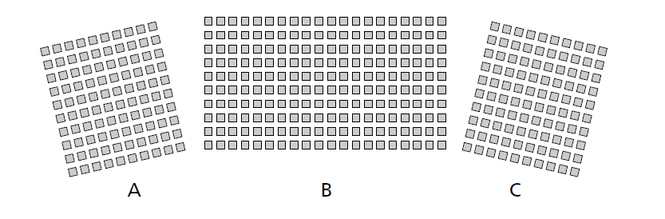

The total number of seats in the theatre is the sum of the number of seats in Sections A, B, and C.

How many seats are in section A?

Let

N represent the number of rows in section A

S represent the number of seats in each row in section A

A represent the total number of seats in Section A

A = N*S

= 10 * 10

= 100

How many seats are in section C?

Let

N represent the number of rows in section C

S represent the number of seats in each row in section C

C represent the total number of seats in Section C

C = N*S

= 10 * 10

= 100

How many seats are in section B?

Let

N represent the number of rows in section B

S represent the number of seats in each row in section B

B represent the total number of seats in Section B

B = N*S

= 10 * (2*10)

= 200

Total number of seats in the theatre = A + B + C = 400.